Initial Assessment Form | Date:
Name
Address
Date of birth
Telephone No.
E-mail
How did you hear about the service?

What is you main reason for attending today?
How long have you had the problem this time?
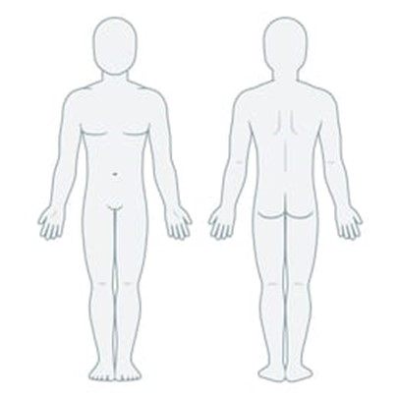 |  | Please shade the body chart in the areas you feel pain or discomfort. Not just the pain you are coming for today, but any other areas.  Mark the body chart with crosses (++) if you experience pins and needles or numbness. |  |  | Clinical use only  PC1:  VAS:  Const. Inter.  Ache  Sharp  Stabbing  Throbbing  PC2:  VAS:  Const. Inter.  Ache  Sharp  Stabbing  Throbbing  PC3:  VAS:  Const. Inter.  Ache  Sharp  Stabbing  Throbbing
What activities make you problem worse?
What can you do to ease the pain/make your condition better?
Is there a pattern of pain throughout the day?
Worse in A.M  Worse in P.M  Better with activity  Worse with activity  No discernible |  |  | □  □  □  □  □
Have you had this problem before? |  |  | Yes □ No □
If yes, please give a brief history of the problem?
Have you visited any other health practitioners with this problem? |  |  |  | Yes □ No □
If so, what kind of practitioner? Did you gain any relief from the problem?
1. |  |  | Yes □ No □
2. |  |  | Yes □ No □
3. |  |  | Yes □ No □
What’s your medical history?
Please list any major illnesses, accidents, surgery, or diseases and approximate dates of these:
Dates: | Details:
What medications do you take? Please list them below:
What is your job title?
How do you spend most of your time at work?
Sitting □ Standing □ Moving □ Lifting □ Other □
Do you participate in any form of exercise? |  |  | Yes □ No □
Please list the type and frequency per week.
Are you allergic to anything?
Please list below:

Clinical use only |  | SQ’s
Red flags |  | Spinal Cord |  |  |  | Cauda Equina
Personal Hx of cancer |  | Dizziness |  | Numbness |  | Bladder
Unremitting pain |  | Dysphasia |  | Nausea |  | Bowel
Thoracic pain |  | Dysphagia |  | Nystagmus  (smooth pursuit) |  | Saddle An.
Night sweats |  | Diplopia |  | Notes
Onset age (<20, >55) |  | Drop Attack
Weight loss

